P.O.Box 114,
Upper Nile State, Malakal,
Republic of South Sudan.
Contacts:
Mobile: +211 (0) 928533454; (0) 9124 54080; (0) 956232503; (0) 913 333333.
Email: hdengawer@gmail.com
His Grace,
The Most Rev. Daniel Deng Bul,
Archbishop of the Episcopal Church of South Sudan and Sudan, bishop of Juba.
P.O Box 110,
Juba.
-----------------------------------------------------------------------------------------------
Subject: Progressive Report
on the situation in Malakal after the recent December attack/incident.

On Tuesday, 23rd of December, 2013 morning; following the spread of violence in many locations in South Sudan and Upper Nile State in particular, in between the soldiers that defected to join Dr. Riak Macar, the former vice president of the Republic of South Sudan, Gen. Salva Kiir and those loyal to his Government. Fighting broke out as a result, whereby the town was divided into two zones and lawlessness began to overshadow the city and several shops were broke into, looted and burnt afterward. Some Government houses, NGOs offices also Government institutions were broke into, even the house of the State Governor was looted as well. Also the house of the Commissioner of police and many others were done the same. The Governor and most ministers run to Renk for their lives, where they stayed until the day the town was recaptured by the Government forces. All shops full of food items, different types of commodities; goods and everything were looted and later on it was set on fire.
We tried to cover up this event to assess the level of damage and impact he lives and the destabilization it has caused on the population of Malakal and it’s normal ways of living. And the following were the results of these findings:-
- Many people have felt their homes during the last week running for their lives in and outside Malakal..
- Many went to seek protection at the United Nation Mission to South Sudan, known as “UNMISS”.
- Many others remained behind doors, in their homes, fearing of being caught in between cross fire.
- Many, especially, the owners Hotels (Ethiopians) were threaten to give up their money and some lost their lives as a result resistance.
- Almost the whole population was affected terribly by this fighting, leaving everybody in critical and difficult position of all kind of needs……especially as the local Market was completely destroyed, and burnt down by the rebels loyal to Dr. Riak Macar Tang.of their properties.
- Many foreign business left the city as a result of their lost
Now, we will go without food for almost two months because there will be no safe route to bring us food from Juba since the Nile River passes through the rebels areas.
So the other alternative might be the Northern front, that Sudan. The Eastern Boarders, which is Ethiopia, would be difficult because there also is the area of the East-Nuer where there is also rebellion.
Assessment of the ECS S&S Losses.

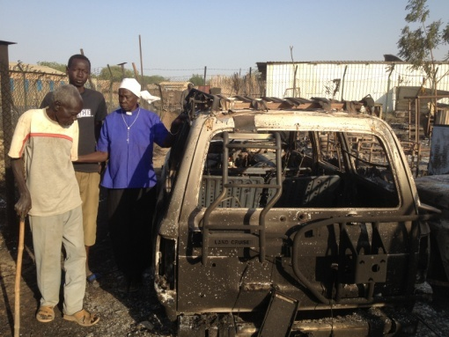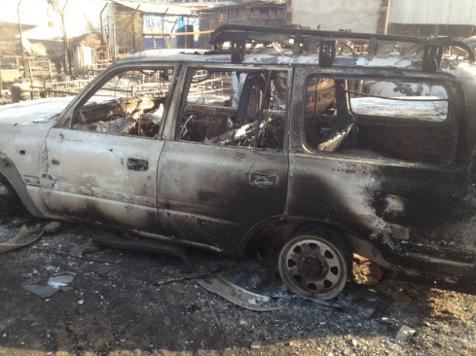
MU literacy Vehicle burnt up during the Malakal rebels attacks..
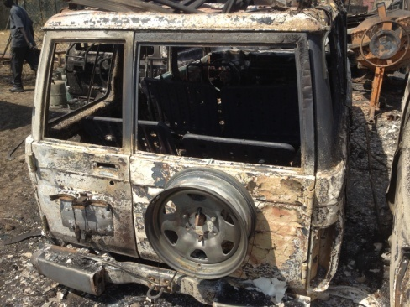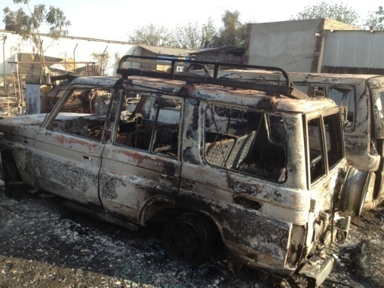
Bishop’s Car of Malakal Diocese…..burnt up during the Malakal crisis.

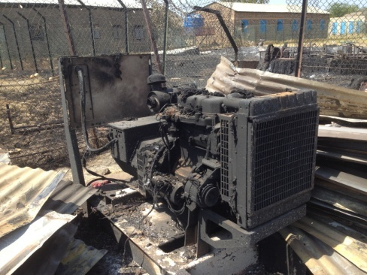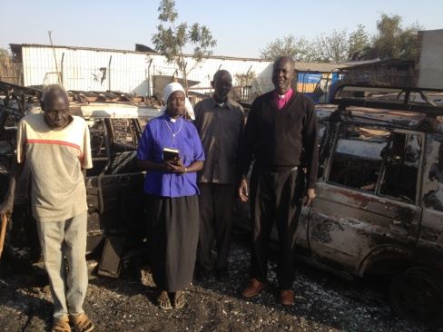
Clinic generator

When the incident was over, the following were the results of the assessment of casualties and losses:-
- Two of our cars; Bishop’s and Literacy Programme, were burnt down to ashes, by a shelling fire that came from the Ethiopian Hotel (known as African Hotel) which was looted first and burnt afterward. There were other two cars besides that which were also burnt.
- The Mother’s Union Centre was broken into and (12) sewing machines were stolen.
- Two huts for the Clinic’s watchman were also destroyed by fire .
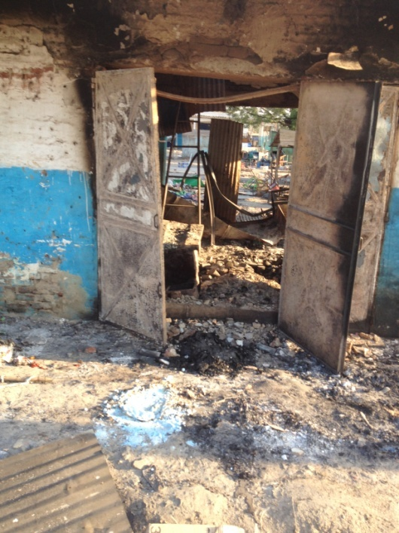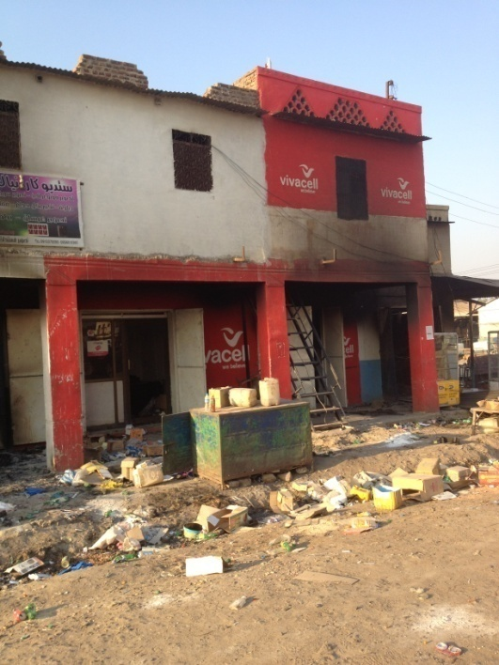
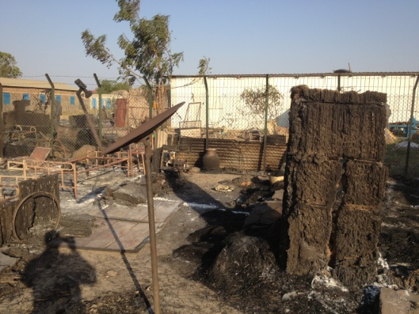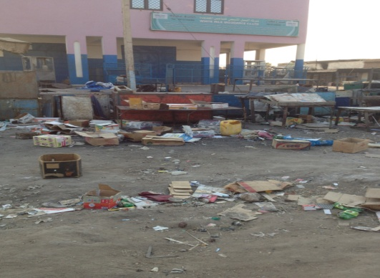
Censes from the Malakal local Maket…..looted and set on fire….
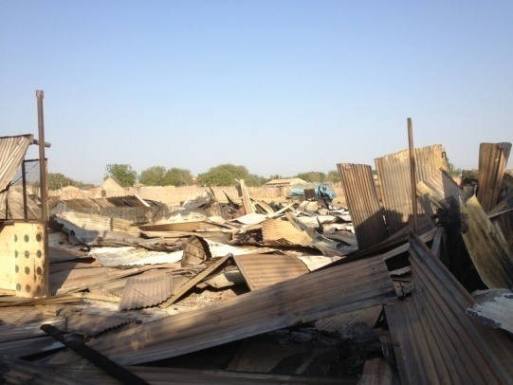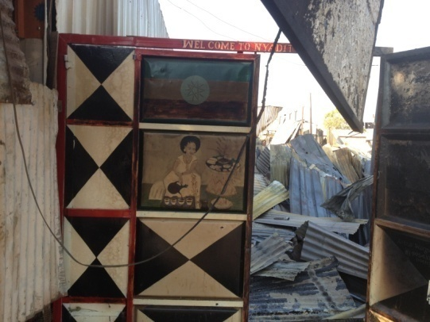
Censes from the Ethiopian Hotel which was looted, its owner killed and was set on fire which went up to ECS- Diocesan Office and burnt up bishop’s car and the MU Literacy vehicle

Assessment of the needs and priorities:-
When we went assess the number of our members who were affected by these crises, we found the following-
- Almost twelve to eight thousands, 8.000-12.000 of the Malakal residents went to seek protection at the UNMISS compound in Malakal.
- Almost 6.000-700 (six hundred to seven hundred) of our members and neighour were affected directly or indirectly by this incident.
(These were clergy, members of the Mother’s Union, our schools students and Christians and their families)
- Several persons were shot and one of our member died as a result because UNMISS could not remove the bullet shot from his body for four day.
The following are the priorities and needs of these people to resume livelihood in the near future and days ahead:-
- Food,
- Medicine,
- Shelter,
- Non-food items.
- Clean water and Sanitation issues.
- Hygiene responds.

COSTINFG ESTIMATES OF OUR DIOCESAN LOSTS DUE TO THE INCIDENT.
S/No | Items | Qty | Unit Price ssp | Total price ssp | Total in $
1. | Moth. Un. Vehicle | 1 | 88.000 | 88.000 | 22.000
2. | Bishop’s car | 1 | 80.000 | 80.000 | 20.000
3. | Diocesan shops | 4 | 12.000 | 48.000 | 12.000
4. | Sewing machines | 12 | 03.000 | 36.000 | 09.000
5. | Chairs | 15 | 250 | 03.750 | 00.937.5
6. | Tables | 3 | 2.500 | 07.500 | 01.875
 | Total |  |  | 263,250 | 65812.5

RCOMMENDATIONS.
- CURRENTLY THE SITUATION IS UNCTERAN AND TENSSE. NOTHING CAN BE DONE TO REPARE THESE DAMEGES UNTIL PEACE IS RESTORED TO WHOLE SOUTH SUDAN AND UPPER NILE REGION.

- THE ABOVE MENTIONED LIST HAS TO REMAIN STANDSTILL UNTIL THINGS COME BACK TO NORMAL.

- WE HAVE TO WORK HARD TO PURCHASE A VEHICLE FOR THE BISHOP WHO IS CURRENTLY IN JUBA, TO FACILITATE HIS MOVEMENTS AND TO HELP HIM CORDINATE THE DIOCESAN WORK FROM THAT END AND MAYBE THROUGHOUT THE EAST AFRICAN BASES.
Thank a lot bless you.
Hope to hear from you as we looking forward for your support in kind and prayers for South Sudan.
The Rt. Rev. Hilary Garang Deng Awer,
Bishop of Malakal, ECSS &S
The Diocesan Assessment Committee, Malakal Diocese

